
TRIBHUWAN UNIVERSITY
INSTITUTE OF ENGINEERING
ADVANCED COLLEGE OF ENGINEERING AND MANAGEMENT

A
Minor Project on
“WOMEN WELLNESS AND SAFETY PLATFORM WITH AI-ASSISTED
EMOTIONAL MONITORING AND VOICE-TRIGGERED EMERGENCY
RESPONSE”

Submitted By:
Saksham Bhujel (ACE080BCT063)
Saroj Singh Dhami (ACE080BCT069)
Sumina Dangol (ACE080BCT084)

Submitted To:
DEPARTMENT OF ELECTRONICS AND COMPUTER ENGINEERING

JUNE,2026
KATHMANDU, NEPAL

EXECUTIVE SUMMARY

Women today face multiple challenges in managing personal health, emotional well-being, and safety. Existing mobile applications generally focus on only one aspect such as menstrual tracking, mood tracking, or emergency assistance, which forces users to rely on multiple separate applications. This fragmented approach reduces convenience, efficiency, and usability. Therefore, there is a need to develop an integrated mobile application that combines essential wellness and safety features in a single platform.
The primary objective of this project is to design and develop a mobile application that supports women’s wellness and safety needs in a simple and user-friendly manner. The system enables users to track their menstrual cycles and receive basic predictions for future cycles. It also allows users to record their daily mood or emotional state, helping them monitor their overall well-being over time. In addition, the application includes an SOS emergency alert feature that allows users to quickly send their real-time location to trusted contacts during emergency situations.
The system will be developed using a structured software development approach involving requirement analysis, system design, implementation, and testing. The mobile application will be built using React Native, while FastAPI will be used for backend development. A lightweight database such as SQLite or PostgreSQL will be used for data storage. GPS services will be integrated to support real-time location sharing, and notification services will be used to alert trusted contacts during SOS activation.
The expected outcome of the project is a fully functional mobile application that integrates menstrual cycle tracking, mood tracking, and an SOS emergency alert system with location sharing. The application will provide a simple and user-friendly interface that allows easy access to all features. It is intended to serve as a practical solution for basic women’s wellness monitoring and personal safety support.
TABLE OF CONTENTS

EXECUTIVE SUMMARY i
LIST OF FIGURES iv
LIST OF TABLES v
LIST OF ABBREVIATIONS vi
1. INTRODUCTION 1
1.1 Background 1
1.2 Problem Statement 2
1.3 Objectives 2
1.3.1 General Objective 2
1.3.2 Specific Objectives 3
1.4 Significance of The Study 3
1.4.1 Significance to Women 3
1.4.2 Significance to Emotional Health 4
1.4.3 Significance to Safety 4
1.4.4 Significance to Learning and Technology 4
2. LITERATURE REVIEW 5
2.1 Menstrual Cycle Tracking Application 5
2.2 Women Safety System using Smart Technologies 5
2.3 AI-Based Emotional Wellness and Safety Systems 6
3. PROPOSED METHODOLOGY 7
3.1 Proposed Research Design / Project Approach 7
3.1.1 System Development Approach 8
3.2 Proposed Model/ Algorithm 9
3.2.1 Menstrual Cycle Prediction 9
3.2.2 AI-Integrated Emotional Monitoring 10
3.2.3 Voice Triggered Emergency Response 10
3.3 TOOLS AND TECHNOLOGIES 11
4. EXPECTED OUTCOMES 12
4.1 Expected Results 12
1) Reproductive Wellness Management 12
2) Emotional Wellness Support 12
3) AI-Assisted Emotional Monitoring 13
4) Emergency Safety Support 13
5) Health Awareness and Educational Support 13
4.1.1 Expected System Workflow 14
4.2 Validation Strategy 14
i. Functional Validation 15
ii. Integration Testing 15
iii. User Interface Validation 15
iv. Emergency Response Validation 16
v. AI Response Validation 16
4.2.1 Validation Process 17
5. TIME SCHEDULE AND BUDGET 18
5.1 Timeline 18
5.1.1 Proposed Project Timeline 18
5.2 Budget……………………………………………………………………………..20
5.2.1 Estimated Project Budget 20
5.2.2 Total Estimated Budget 21
REFERENCES 22

LIST OF FIGURES

Figure 1: System Architecture of the Proposed System 7
Figure 2: Expected System Workflow 14
Figure 3: System Validation Process 17

LIST OF TABLES

Table 1: Proposed System Development Approach 8
Table 2: Tools and Technologies Used 11
Table 3: Timeline Estimation of the Project 18
Table 4: Budget Estimation of the Project 20

LIST OF ABBREVIATIONS

SOS – Emergency Alert Signal
GPS – Global Positioning System
API – Application Programming Interface
SDLC – Software Development Life Cycle
UI – User Interface
DB – Database

INTRODUCTION

1.1 Background
Women’s health, emotional well-being and personal safety are important for living a quality life. Mental and physical wellness challenges such as irregular menstrual cycles, mood disorders, and stress continue to affect millions of women, often without adequate digital support tools. With the rapid increment in the use of smartphones and technologies, mobile applications have become a popular tool to manage menstrual health, tracking wellness, and access safety services.
Menstrual health plays a vital role in a woman's overall physical and emotional wellness. Regular tracking of menstrual cycles, symptoms, and related health indicators can assist women in understanding their bodies better and identifying potential health concerns at an early stage. Similarly, emotional well-being has become an increasingly important aspect of overall health. Although journaling and mood tracking have proven beneficial in promoting self-awareness and emotional regulation, many women lack accessible tools that can provide meaningful insights from their emotional patterns.
In addition to health concerns, personal safety remains a major issue for women. Situations involving harassment, threats, or emergencies often require immediate access to assistance. While smartphones provide certain emergency functionalities, these features are often limited in personalization and may not integrate with broader wellness monitoring systems.
Therefore, this project proposes the development of a Women Wellness and Safety Platform with AI-Assisted Emotional Monitoring and Voice-Triggered Emergency Response. Combining these functionalities, the system seeks to provide women with a holistic digital platform that supports both preventive healthcare and emergency preparedness.

1.2 Problem Statement
Women often face challenges related to reproductive health, emotional well-being, and personal safety. There are many existing applications, but they mainly focus on only one area such as menstrual tracking, mental wellness, or emergency assistance which becomes the reason for women to have multiple applications to manage their health, emotions, and safety needs, which can be inconvenient and less effective.
Most current systems provide only basic features such as period prediction, mood logging, or manual SOS activation, and they lack intelligent emotional monitoring, personalized wellness recommendations, and hands-free emergency response support. In addition, awareness regarding women’s health conditions such as PCOS, menstrual disorders, and emotional stress remains limited.
Furthermore, traditional mood tracking and journaling applications generally store user data without providing meaningful analysis or personalized recommendations. Consequently, users may find it difficult to recognize emotional patterns, stress triggers, or behavioral trends that could affect their well-being.
Hence, there is a need for an integrated Women Wellness and Safety Platform that combines menstrual health tracking, emotional wellness support, AI-assisted emotional analysis, educational awareness, and voice-triggered emergency response services into a single system to provide a more convenient and supportive solution for women.

1.3 Objectives

1.3.1 General Objective
To design and develop an integrated Women Wellness and Safety Platform that supports reproductive health management, emotional well-being monitoring, health awareness, and emergency response through modern mobile and web technologies.

1.3.2 Specific Objectives
- To provide wellness tools such as menstrual cycle tracking, period prediction, symptom logging, energy level monitoring, and cycle history visualization.
- To support emotional well-being through daily mood tracking, journaling, breathing exercises, and relaxing audio content.
- To use Google Gemini API for predicting menstrual cycles based on cycle history, symptoms, and emotional trends without requiring complex model training.
- To improve user safety through voice-activated emergency assistance, emergency contact alerts, and real-time location sharing.
- To educate users about women's health topics such as PCOS, ovarian cysts, breast cancer, cervical cancer, and menstrual disorders.
- To create a single platform for both mobile and web using React Native, React.js, Fast API, and PostgreSQL, so users can access wellness, emotional support, and safety features in one place.
- To ensure secure user authentication using JWT and safely store health-related data in PostgreSQL or SQLite database.

1.4 Significance of The Study
The Women Wellness and Safety Platform is significant because it helps women with aspects of their lives through one digital solution. The Women Wellness and Safety Platform combine things like health, emotional support, health information and safety features to make women lives better.

1.4.1 Significance to Women
The Women Wellness and Safety Platform give women one place to keep track of their menstrual health, emotions and journals. Women can also use the Women Wellness and Safety Platform to relax and get help in emergencies. This makes it easier for women to take care of themselves without using different apps.

1.4.2 Significance to Emotional Health
The Women Wellness and Safety Platform use intelligence to help women understand their emotions. Women can see patterns in their emotions and behaviors that they might not have noticed otherwise. The Women Wellness and Safety Platform give women personalized advice and tools to help them manage stress.

1.4.3 Significance to Safety
The Women Wellness and Safety Platform have an emergency feature that women can use with their voice. The Women Wellness and Safety Platform can also send messages to emergency contacts and share locations. These features help women get help quickly in emergencies.

1.4.4 Significance to Learning and Technology
The Women Wellness and Safety Platform project shows how technology can be used to solve problems. The Platform is an example of how technology can be used to help people.

LITERATURE REVIEW

2.1 Menstrual Cycle Tracking Application
A study evaluated the medical reliability and data privacy practices of menstrual cycle tracking applications [1]. The researchers assessed 18 applications available on the Apple App Store and Google Play Store using a combined scoring framework based on Digital Health Application (DiGA) guidelines, the Mobile App Rating Scale (MARS), and additional evaluation criteria. The study found significant shortcomings in both medical transparency and data privacy. Many apps requested permissions that were not essential for menstrual tracking, while many failed to disclose the algorithms used to calculate fertile windows. In addition, none of the applications provided two-factor authentication, raising concerns regarding user data security. However, the study focused solely on menstrual tracking applications and did not address emotional wellness support, AI-driven assistance, or personal safety features. This limitation highlights a gap in existing solutions and supports the need for the proposed Women Wellness and Safety Platform, which aims to integrate reproductive health management, emotional wellness support, AI-powered assistance, and emergency safety services within a secure and transparent environment.

2.2 Women Safety System using Smart Technologies
An intelligent women safety system, Stree Raksha, was developed to integrate real-time location tracking, emergency alert mechanisms, and emotional wellness features [2]. The system enables users to track their journeys by specifying start and end destinations and sends safety alerts at predefined intervals. If the user fails to respond, an automatic SOS alert is triggered and shared with guardians, nearby police stations, and community users within a 5 km radius. The system also includes a dedicated SOS button that transmits the user’s personal details and live location to the nearest police station. The system was evaluated through emergency alert testing, GPS accuracy assessment, usability testing, performance analysis, and reliability testing. The results indicated that emergency alerts were delivered within seconds, location tracking operated in real time, and the system demonstrated low latency and stable performance during prolonged use. However, limitations were identified, including reduced GPS accuracy in weak signal areas, dependence on internet connectivity, and limited functionality under certain conditions. Future improvements such as voice-based activation, AI-driven risk detection, wearable device integration, multilingual support, and offline alert mechanisms were suggested. These findings are relevant to the proposed Women Wellness and Safety Platform, as they highlight the importance of real-time tracking and emergency response while identifying opportunities for improved accessibility, intelligence, and reliability.

2.3 AI-Based Emotional Wellness and Safety Systems
An AI-based emotional wellness and safety application for women, NIRAAH, was developed to support both emotional well-being and personal safety within a single platform [3]. The system integrates multimodal emotion recognition techniques, including facial expression analysis, speech emotion detection, and text-based sentiment analysis, to identify users’ emotional states. Based on the detected emotional condition, an AI-powered conversational module generates appropriate responses to provide emotional support. The system also includes emergency alert and location-sharing features to assist users during critical situations. The application was evaluated through functional testing of key modules such as user authentication, emotion detection, data synchronization, AI interaction, and emergency alert activation. The results showed that the system successfully integrates emotional wellness support with safety mechanisms in a single platform. However, the study highlights concern regarding sensitive data handling and emphasizes the need for stronger privacy protection and improved integration of emotional and safety features. These findings are relevant to the proposed Women Wellness and Safety Platform, as they support the importance of combining emotional support with safety and ensuring data privacy and reliability.

PROPOSED METHODOLOGY

3.1 Proposed Research Design / Project Approach
The proposed system follows a full-stack application development approach to design and implement an integrated Women Wellness and Safety Platform. The project combines reproductive wellness management, emotional wellness support, AI-assisted emotional monitoring, educational awareness, and emergency safety services into a single mobile and web-based platform.
The development process will follow a modular and iterative approach where individual features are developed, tested, and integrated progressively. This approach helps simplify system development and allows continuous improvement of system functionalities during implementation.
The system architecture consists of four major components:
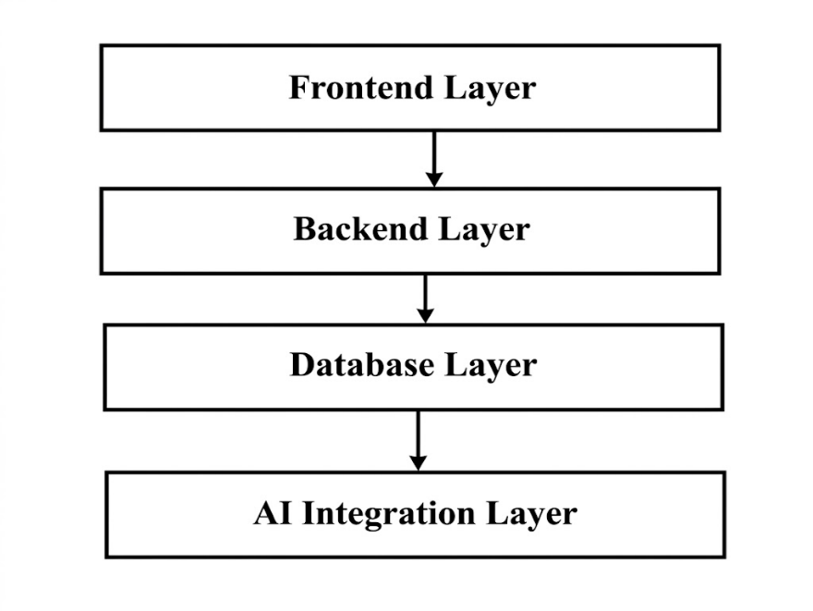
Figure 1: System Architecture of the Proposed System
The proposed system consists of:
- Mobile application developed using React Native
- Web application developed using React.js
- Backend API developed using FastAPI
- PostgreSQL/SQLite database for data storage
- Google Gemini API for emotional analysis

3.1.1 System Development Approach
Table 1: Proposed System Development Approach
PHASE | DESCRIPTION
Requirement Analysis | Identify system requirements based on women's wellness needs, emotional support requirements, safety concerns, and limitations of existing applications.
System Design | Design the overall system architecture, database schema, API structure, user interface, and application workflow.
Frontend Development | Develop mobile and web interfaces for user interaction, dashboards, navigation, forms, and API communication.
Backend Development | Develop server-side functionalities including authentication, API management, business logic, database operations, AI integration, and emergency response features.
Database Development | Create and manage the database for storing user information and application data.
AI Integration | Integrate AI for emotional monitoring, mood analysis, emotional insight generation, and wellness recommendations.
Testing and Evaluation | Test the system for functionality, reliability, performance, and usability.

3.2 Proposed Model/ Algorithm
The proposed system uses a combination of rule-based processing and AI-assisted analysis techniques. This Women Wellness and Safety Platform combine rule-based algorithms and AI-assisted analysis to provide wellness tracking, emotional monitoring, and emergency response services. The system consists of three main modules: Menstrual Cycle Prediction, AI-Assisted Emotional Monitoring, and Voice-Triggered Emergency Response.

3.2.1 Menstrual Cycle Prediction
The menstrual cycle prediction module estimates the user's next expected menstrual period using historical cycle records. The algorithm follows a rule-based approach where previous cycle dates are stored, and the average cycle length is calculated.
Process:
- Store previous cycle dates
- Calculate average cycle duration
- Predict upcoming cycle date
Formula:
Predicted Date = Last Cycle Date + Average Cycle Length

3.2.2 AI-Integrated Emotional Monitoring
The emotional monitoring module utilizes the Google Gemini API to analyse user-provided mood logs and journal entries. Machine Learning techniques are used to identify:
- mood logs,
- journal entries,
- and emotional patterns.
The AI system performs sentiment analysis and generates:
- emotional summaries,
- stress detection,
- wellness suggestions,
- breathing exercise recommendations,
- motivational messages.

3.2.3 Voice Triggered Emergency Response
The emergency response module provides rapid assistance through voice-activated SOS functionality. The module uses predefined emergency keywords/phrases or volume button press to trigger safety actions automatically.
Process:
- Detect predefined emergency phrase or Volume button press thrice
- Activate SOS alert
- Retrieve live GPS location
- Send alert and location to emergency contacts

3.3 TOOLS AND TECHNOLOGIES
Table 2: Tools and Technologies Used
Category | Tools and Technology | Purpose
Mobile Frontend | React Native | Mobile application development
Web Frontend | React JS | Web application development
Backend Framework | Fast API | REST API and backend services
Database | PostgreSQL/ SQLite | Data storage and management
Authentication | JWT Authentication | Secure user login and authorization
AI Integration | Google Gemini API | Emotional analysis and recommendations
UI/UX Design | Figma | Interface design
Programming Languages | Python, JavaScript | Frontend and backend coding for development
Version Control | Git and GitHub | Source code management
Development Environment | Visual Studio Code / Antigravity | Code editing and debugging
Location Services | Expo Location API/ Google Map API | GPS location sharing
Voice Recognition | React Native Voice/ Speech Recognition API | Voice-triggered SOS detection

EXPECTED OUTCOMES

4.1 Expected Results
The proposed Women Wellness and Safety Platform is expected to provide an Integrated digital solution for women’s reproductive wellness, emotional well-being, health awareness, and personal safety.
The expected outcomes of the project are as follows:

Reproductive Wellness Management
The system is expected to:
- track menstrual cycle data,
- predict upcoming periods,
- record symptoms and mood changes,
- and display cycle history.
This feature will help users better understand their reproductive health patterns and maintain personal wellness records.

Emotional Wellness Support
The platform is expected to provide:
- daily mood tracking,
- journaling functionality,
- breathing exercises,
- and relaxation support.
The system will help users monitor emotional conditions and encourage healthy emotional habits.

AI-Assisted Emotional Monitoring
The integration of Google Gemini API is expected to:
- analyse journal entries and mood logs,
- detect emotional patterns,
- identify stress-related behaviour
- and generate personalized wellness recommendations.
The AI system is expected to improve emotional awareness by providing different suggestions.

Emergency Safety Support
The proposed system is expected to improve user safety through:
- voice-triggered SOS activation,
- emergency contact notification,
- and real-time location sharing.
These features are expected to provide faster emergency response support during unsafe situations.

Health Awareness and Educational Support
The system is expected to provide awareness content related to:
- PCOS,
- ovarian cysts,
- breast cancer,
- cervical cancer,
- and menstrual disorders.
This feature is expected to improve health awareness.

4.1.1 Expected System Workflow
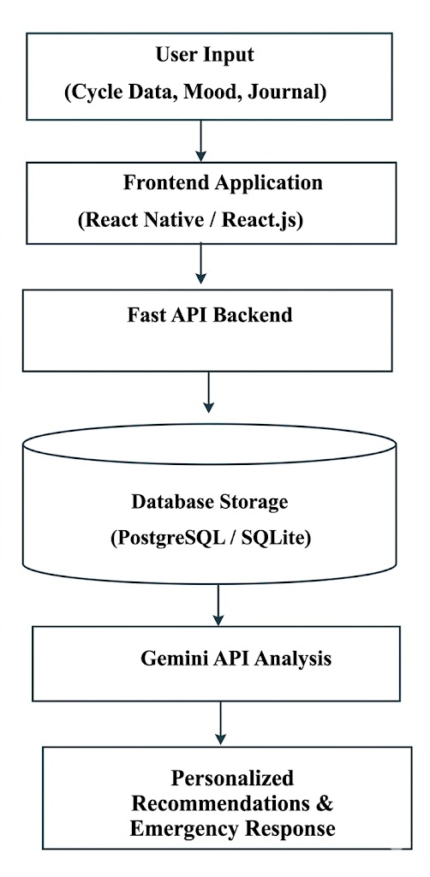
Figure 2: Expected System Workflow

4.2 Validation Strategy
The proposed system will be validated through functional testing, integration testing, and user-based evaluation to ensure that all modules operate correctly and efficiently.
We have proposed to consider different strategies techniques for the system validation:

Functional Validation
Each module of the system will be tested individually to verify whether it performs its intended functionality correctly.
The following functionalities will be tested:
- user registration and login,
- menstrual cycle tracking,
- mood logging,
- journal entry management,
- AI emotional analysis,
- voice-triggered SOS,
- and emergency notification system.

Integration Testing
Integration testing will be performed to verify communication between:
- frontend applications,
- backend APIs,
- database system,
- and Gemini API services.
This testing ensures smooth data flow across all system components.

User Interface Validation
The mobile and web interfaces will be evaluated for:
- usability,
- responsiveness,
- accessibility,
- and ease of navigation.
The system aims to provide a simple and user-friendly experience.

Emergency Response Validation
The emergency system will be tested by:
- triggering SOS voice commands,
- verifying emergency notifications,
- and checking real-time location sharing functionality.
This testing ensures that emergency services operate correctly during critical situations.

AI Response Validation
The AI-generated emotional recommendations will be validated by checking:
- relevance of suggestions,
- emotional accuracy,
- and consistency of generated responses.
Sample emotional inputs will be tested to evaluate AI behaviour.

4.2.1 Validation Process

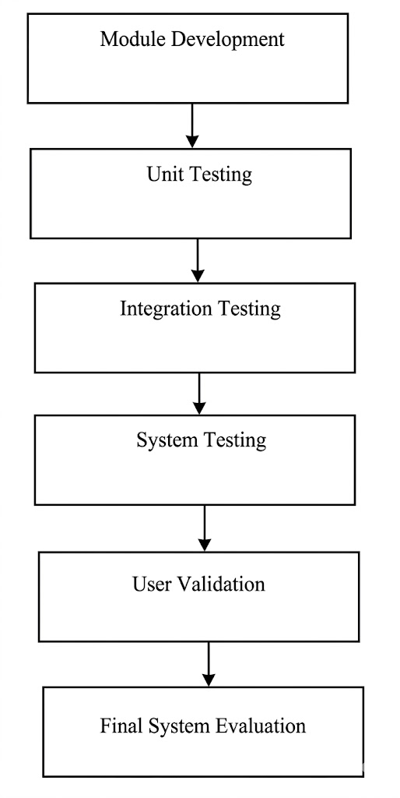
Figure 3: System Validation Process

TIME SCHEDULE AND BUDGET

5.1 Timeline
The proposed Women Wellness and Safety Platform will be developed within a period of two months using an iterative and modular development approach. The project timeline includes requirement analysis, system design, frontend and backend development, AI integration, testing, and documentation.

5.1.1 Proposed Project Timeline
Table 3: Timeline Estimation of the Project
S.N. | Activities | W1 | W2 | W3 | W4 | W5 | W6 | W7 | W8
1 | Requirement Analysis and Proposal | ✓ | ✓
2 | System Design and UI/UX Design |  | ✓ | ✓
3 | React Native Mobile App Development |  | ✓ | ✓ | ✓
4 | React.js Web Application Development |  | ✓ | ✓ | ✓
5 | Fast API Backend Development |  | ✓ | ✓ | ✓ | ✓
6 | Database Design and Integration |  |  | ✓ | ✓
7 | Gemini API Integration |  |  |  |  | ✓ | ✓
8 | SOS and Location Sharing Module |  |  |  |  | ✓ | ✓
9 | Testing and Debugging |  |  |  |  |  | ✓ | ✓
10 | Documentation and Report Preparation |  |  |  |  |  | ✓ | ✓ | ✓
11 | Final Review and Presentation Preparation |  |  |  |  |  |  |  | ✓

5.2 Budget
The proposed system mainly uses open-source technologies and free development tools. Therefore, the estimated development cost is minimal.

5.2.1 Estimated Project Budget
Table 4: Budget Estimation of the Project
S.N. | Item/Service | Estimated Cost
1 | React Native | Free
2 | React JS | Free
3 | Fast API | Free
4 | Postgres SQL/ SQ lite | Free
5 | Google Gemini API | Free
6 | Figma | Free
7 | Visual Studio Code | Free
8 | GitHub | Free
9 | Internet and Testing | 1000
10 | Documentation and Printing | 700
–––––11 | Miscellaneous Expenses | 1500

5.2.2 Total Estimated Budget
Total Estimated Cost = 3200 NPR
The estimated budget demonstrates that the proposed Women Wellness and Safety Platform can be developed cost-effectively using modern open-source technologies and free development resources.

REFERENCES

[1] | Y. Nielsen-Tehranchian, V. Strotbaum and M. Pobiruchin, "Menstrual Cycle Tracking Apps: An Applied Combined Medical and Data Privacy Scoring," Studies in Health Technology and Informatics, vol. 307, pp. 208-214, 2023.
[2] | T. Sriranjani, P. Devarakonda, M. Alampally, D. C. Kajjurapu, S. Nookala and N. Shaik , "Stree Raksha: An Intelligent Women Safety System using Smart Technologies," International Journal of Engineering Research & Technology (IJERT), vol. 15, no. 4, 2026.
[3] | U. Mogili, P. S. Hasvitha, C. L. Prasaana, M. S. Kumar, K. R. Kumar, P. Hema, R. K. Jyothika and L. Naveen, "NIRAAH – An AI powered Emotional Wellness and Safety Application for Women," International Journal of Innovative Research in Technology (IJIRT), vol. 12, no. 11, pp. 416-421, 2026.

